Nama : Rezki Fauzi Firmansyah

Program : Quality Engineer - Kampus Merdeka Batch 6

Kelas : A

Materi : 26 - AI Tools for QA

AI Testcase :

(<https://docs.google.com/spreadsheets/d/1t5d_bPNyAj_AjwXDsfH57CDdCegTlKAxg1ddQuyPjD8/edit?usp=sharing>)

**Fitur Sign Up and Login  
Test Scenario 1:** Verify Sign up with valid data

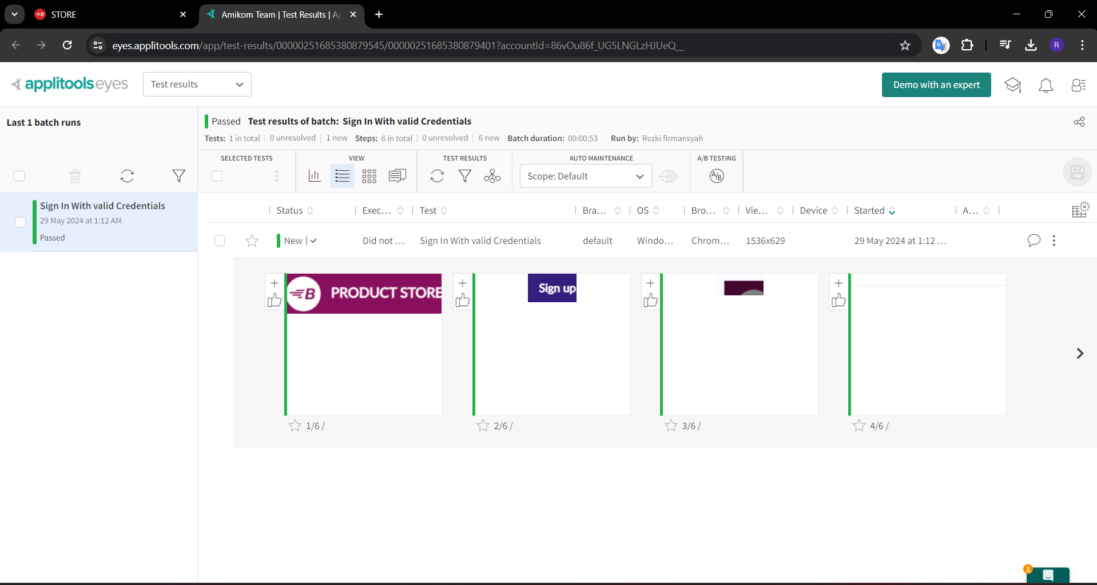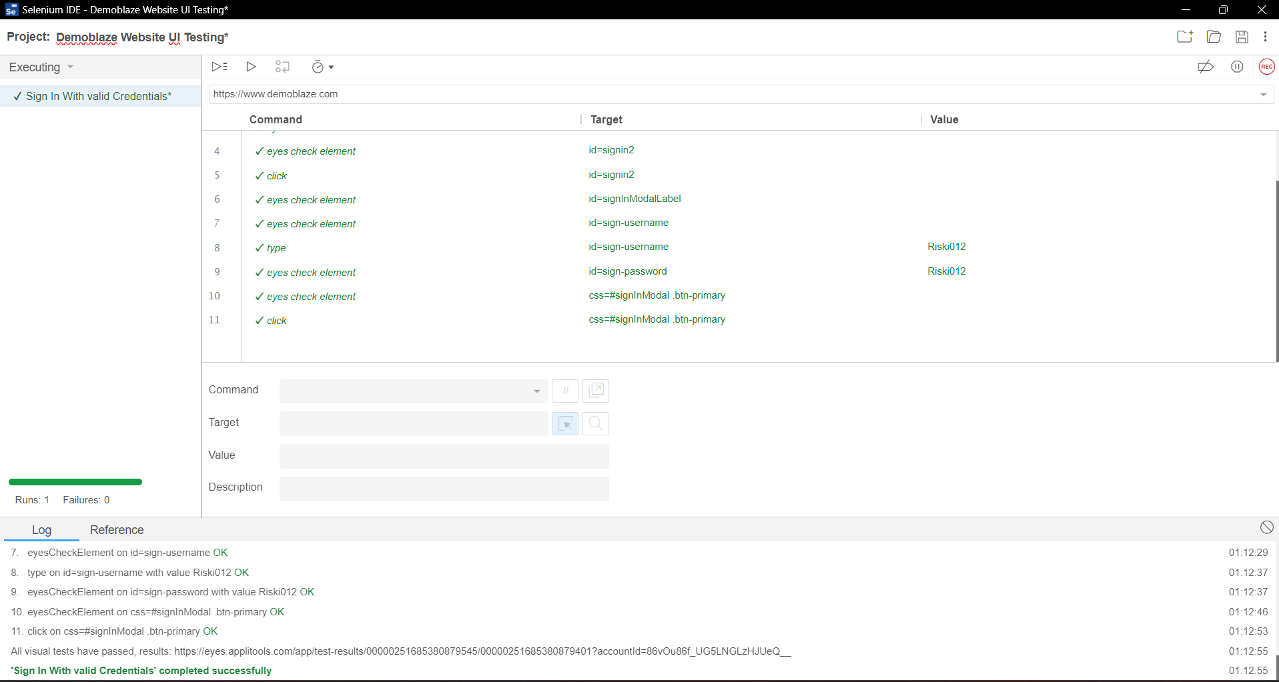

**Test Scenario 2:** Verify Sign up with invalid data  
  
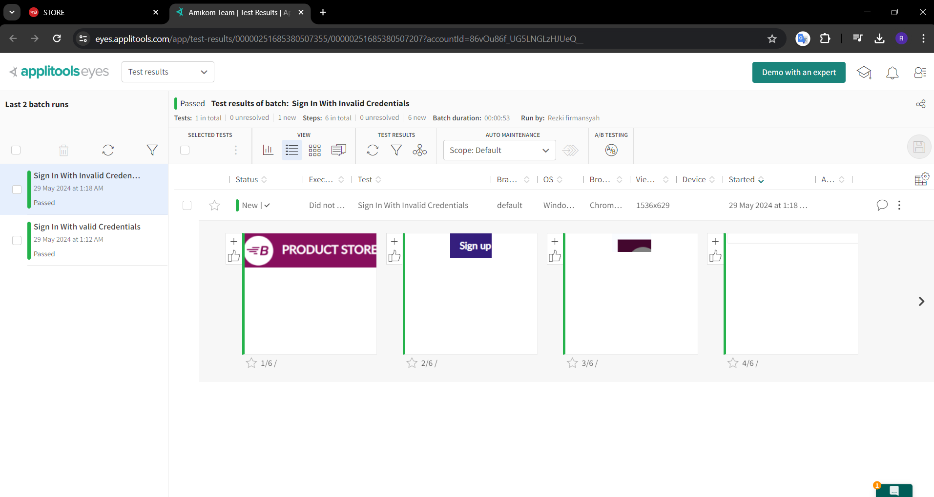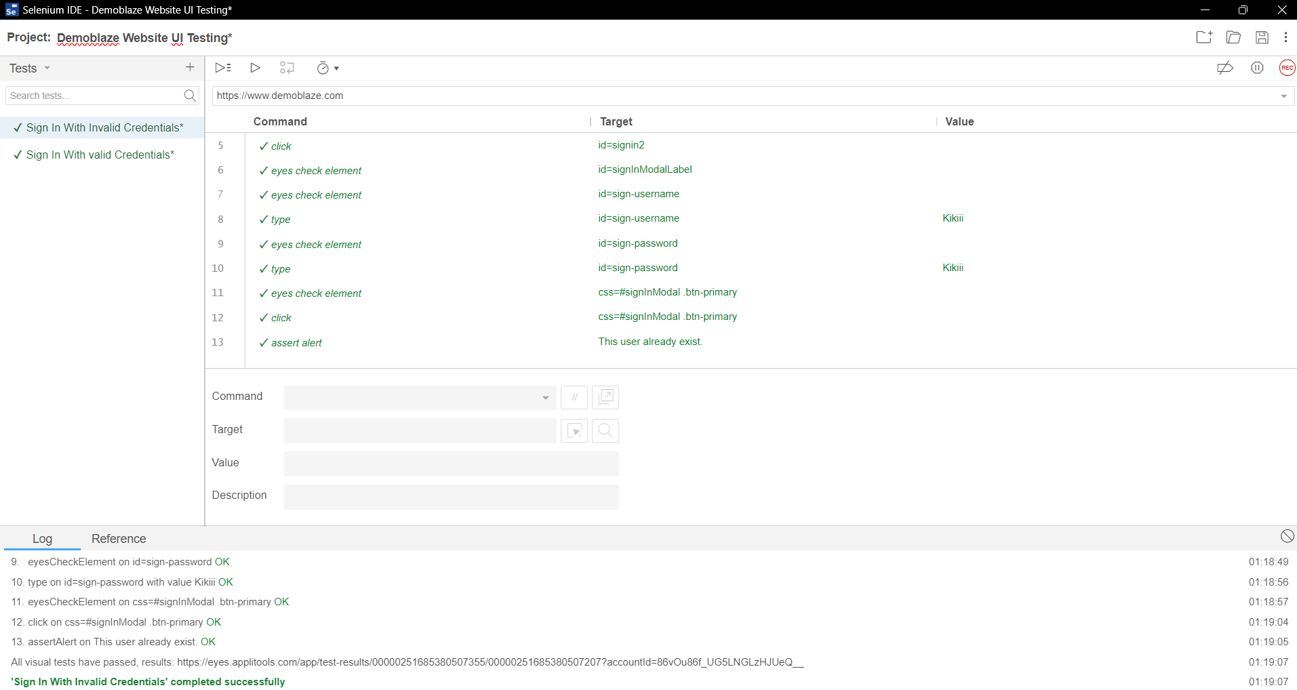

**Test Scenario 3:** Verify Login With Valid Data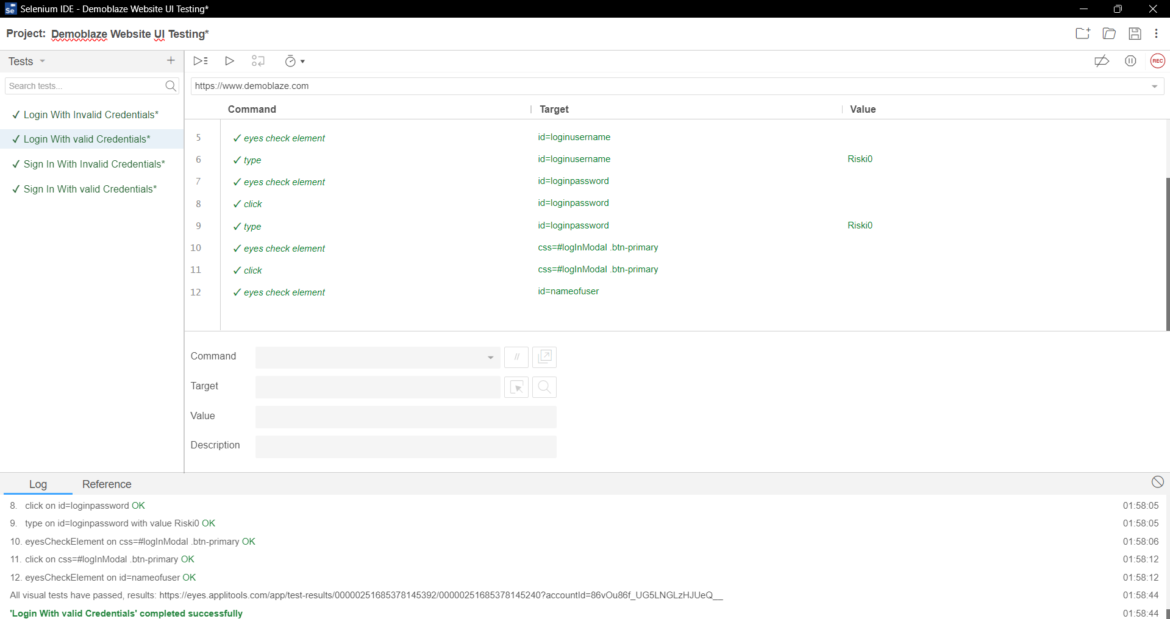

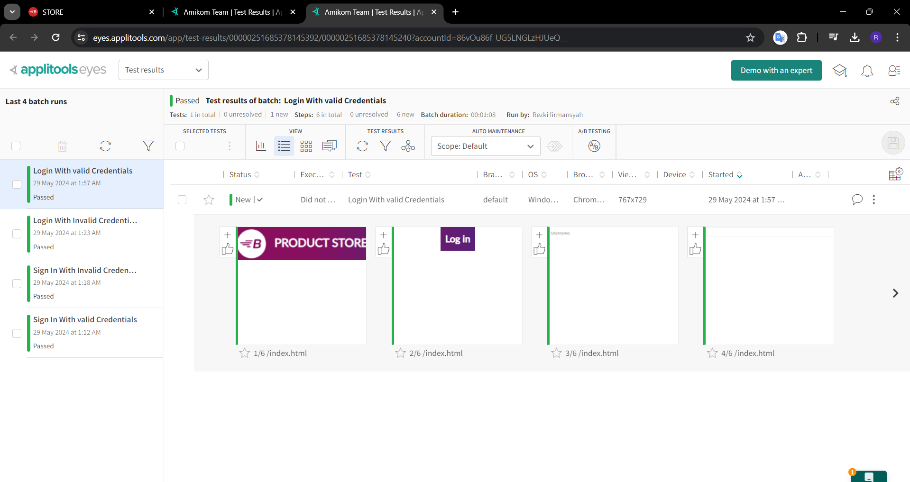

**Test Scenario 4:** Verify Login With Invalid Data

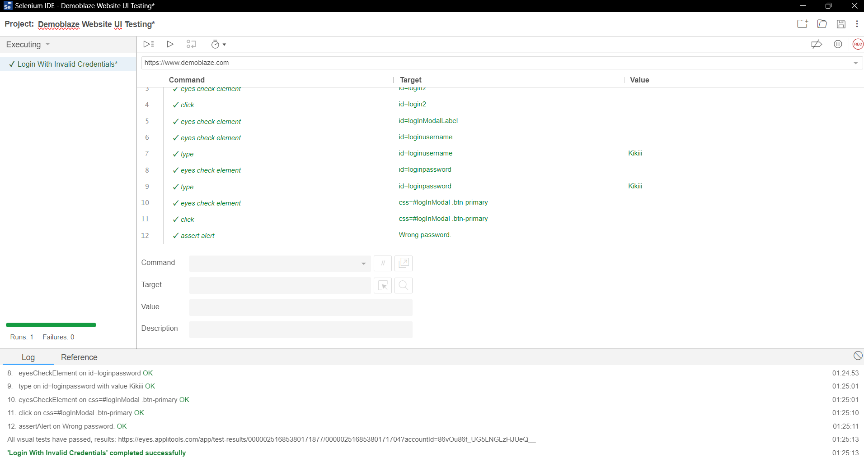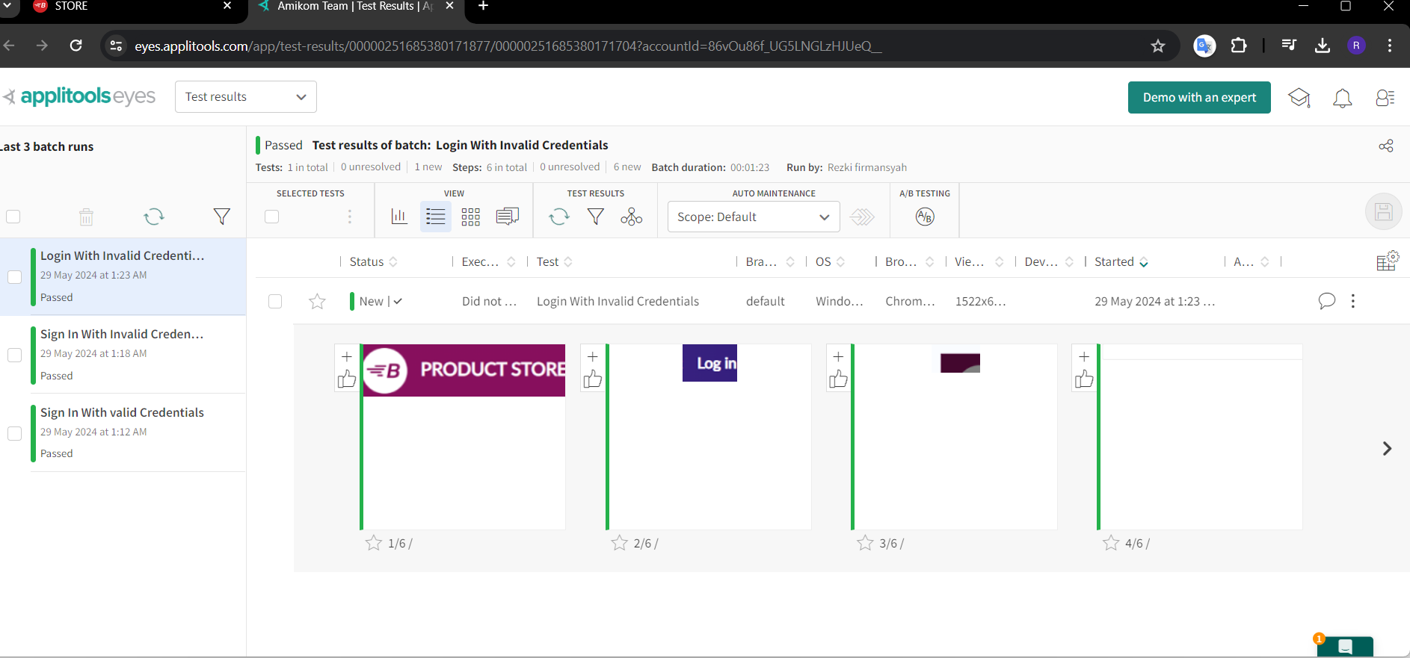

**Fitur Purchase**

**Test Scenario 1:** Verify Making Purchases

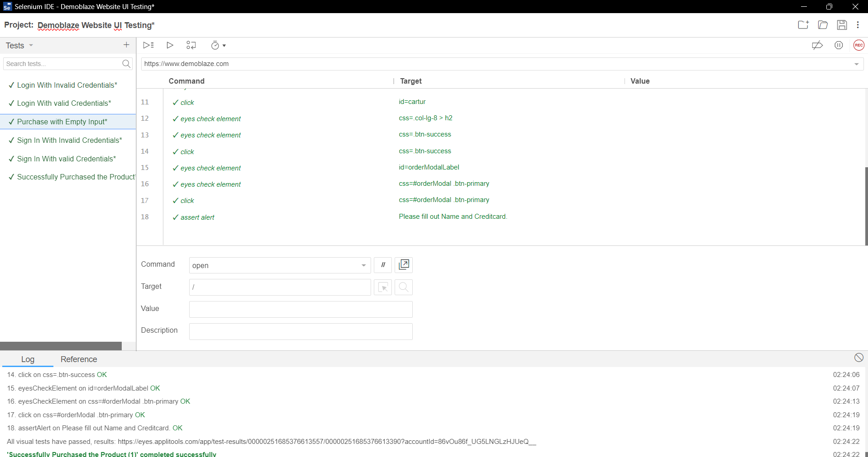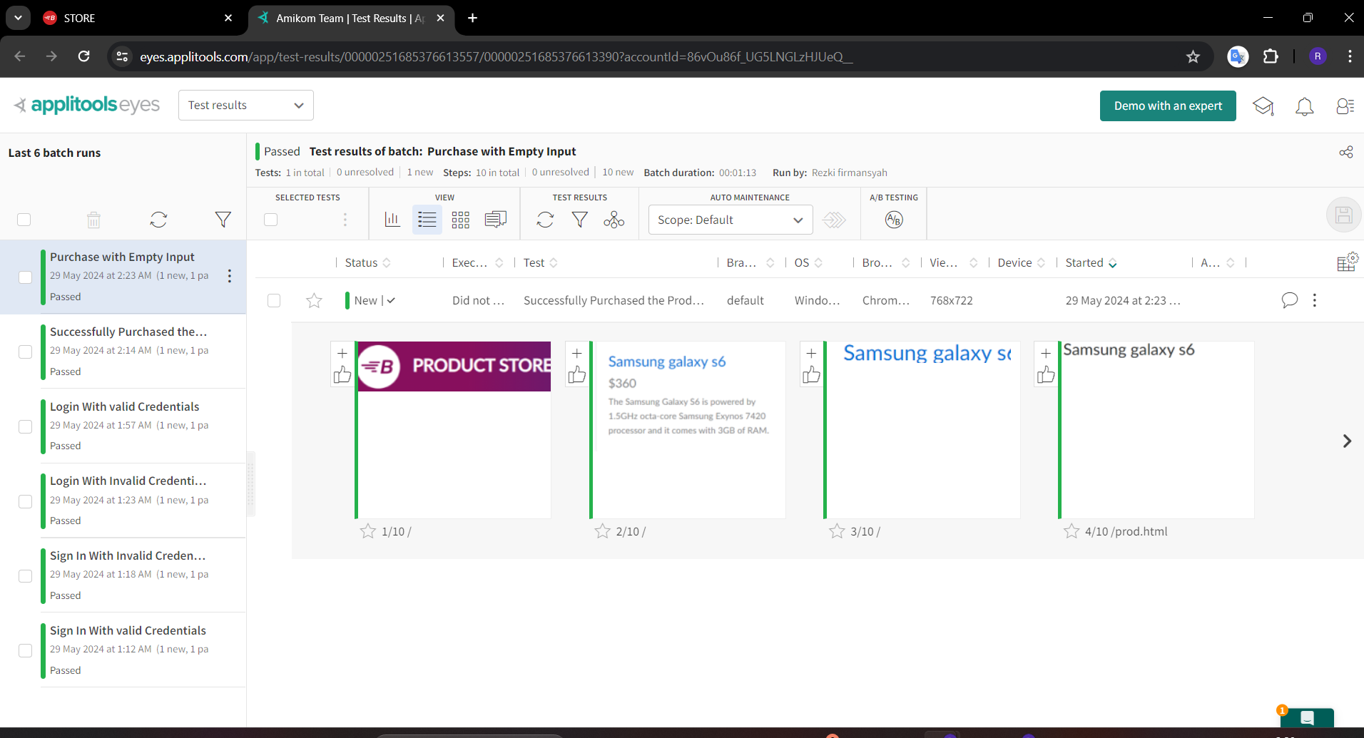

**Test Scenario 2:** Verify Making Purchases with Empty Input